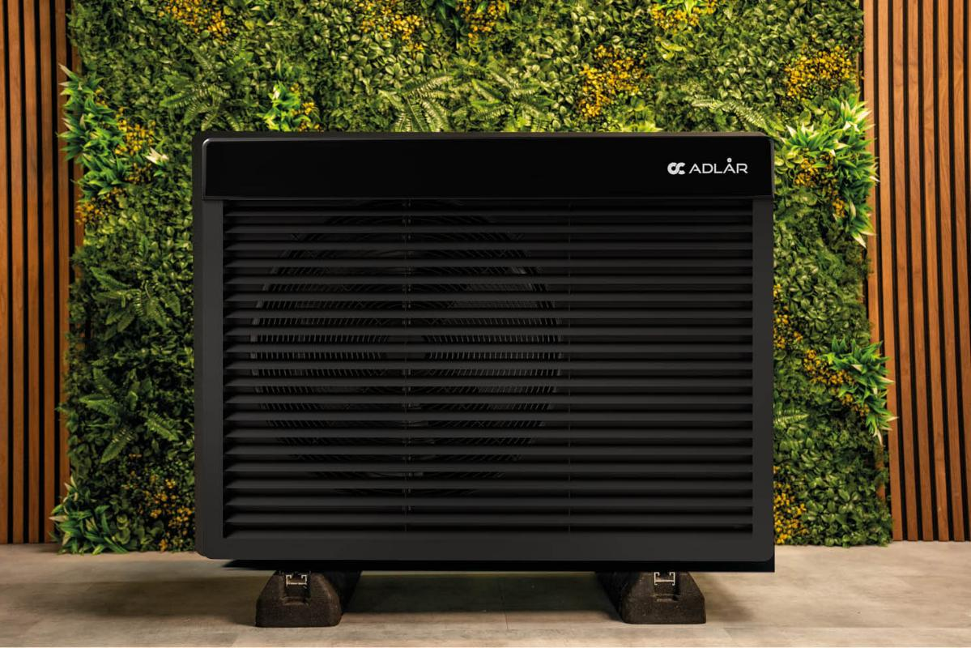

PICTURE OF HOME

Introduction:
This Design and Access Statement supports a planning application for the installation of an Air Source Heat Pump (ASHP) at [Address].
The proposal seeks to improve the property’s energy efficiency and reduce carbon emissions in line with national and local environmental objectives.
Site Context:
The site is a [type of property, e.g. “two-storey semi-detached dwelling”] located within a [e.g. “residential area of XYZ borough” / “conservation area” / “rural setting”], and benefits from sufficient external space for the installation of an ASHP without encroaching on public pathways or neighbouring properties.
Site Overview:
[e.g. “Name of Property” / “Historic Reference Number” / “Property Details”]
Site Context:
Proposed Development
- Technology: Air Source Heat Pump Adlår Castra Aurora II
- Location: [e.g. “mounted at ground level to the side of the property”]
- Size: Unit dimensions see following section
- Fixing: Placed on a concrete pad with anti-vibration brackets to reduce noise and vibration.
- Screening: [e.g. “A timber fence/enclosure will provide visual screening while ensuring airflow compliance”]
Appearance
The unit is of neutral black colour, modern in design, and will be positioned discreetly to minimise visual impact. If necessary, soft landscaping or screening will be used to harmonise it with the existing surroundings.

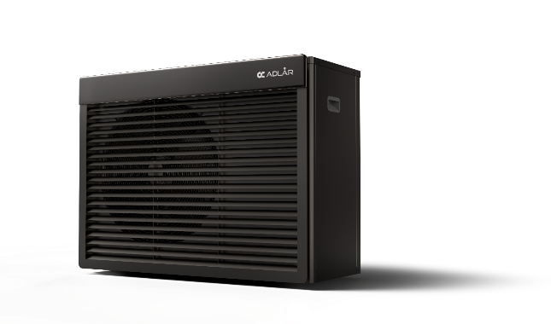
Installation Impact
- Minimal Structural Impact: The installation will require only one 4" (100mm) hole through the external wall to provide a route for water pipework between the internal system and the ASHP.
- Reversible Installation: The heat pump is fully removable with no lasting alterations to the structure, allowing the property to be restored to its original condition if required.
- Comparable to Traditional Systems: The physical impact of installation is no greater than that of conventional boiler systems, with the key difference being the external siting of the ASHP.
- Preservation of Historic Fabric: For listed or historically significant properties, the installation will not impact any protected or original building elements. As the ASHP system is non-intrusive and reversible, it preserves the historical and architectural integrity of the building.

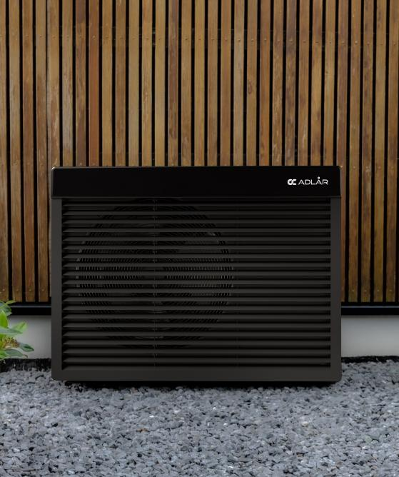

PICTURE OF HOME
Access Considerations
Installation Access
Access for the installation will be via existing entry points to the property. No alterations are required to current pedestrian or vehicle access routes.

Maintenance Access
Adequate clearance (typically 1 metre) will be maintained around the unit to allow safe and compliant access for routine maintenance or servicing, in accordance with manufacturer specifications.

Noise Impact
A noise impact assessment has been considered. The ASHP model selected complies with MCS Planning Standards (MCS 020) and Part E of Building Regulations (resistance to sound, ensuring minimal disturbance to occupants and neighbouring properties.
A noise assessment will be attached separately to the application.
MCS 020 Standard: https://mcscertified.com/wp-content/uploads/2025/03/MCS-020-a-Issue-1.0-Final.pdf

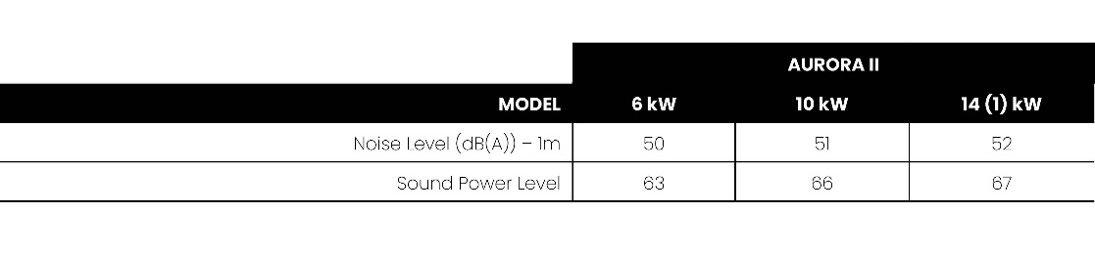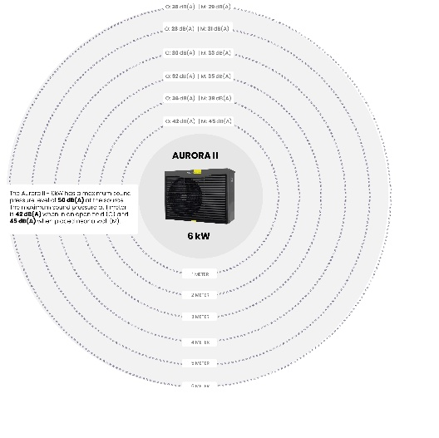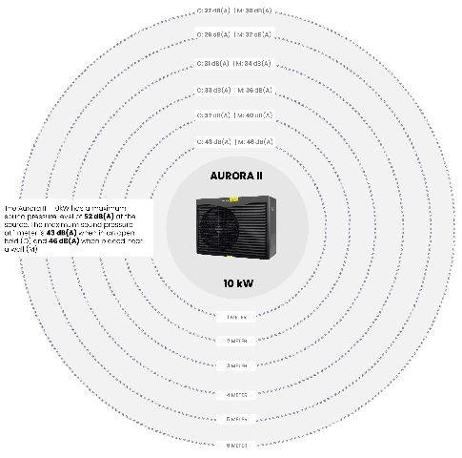
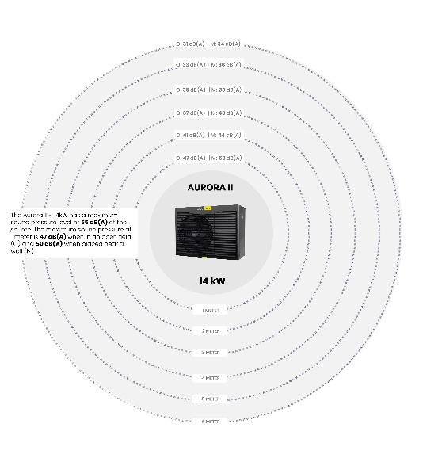
Environmental and Sustainability Benefits
The ASHP replaces or supplements a traditional fossil-fuel heating system and:
- Reduces household carbon emissions
- Improves EPC (Energy Performance Certificate) rating
- Aligns with local climate strategies and national net-zero targets

Heritage & Conservation Area Considerations
Although the property lies within a protected zone. The installation has been carefully designed to avoid any adverse effect on the visual amenity or historic character of the area. It will not affect any listed structures or fabric.

Conclusion
The proposed installation of an Air Source Heat Pump represents a sustainable and low-impact improvement to the property. It is designed to be visually unobtrusive, acoustically compliant, and fully accessible for maintenance. The development supports wider environmental goals without compromising the character or access of the site.

Dimensions
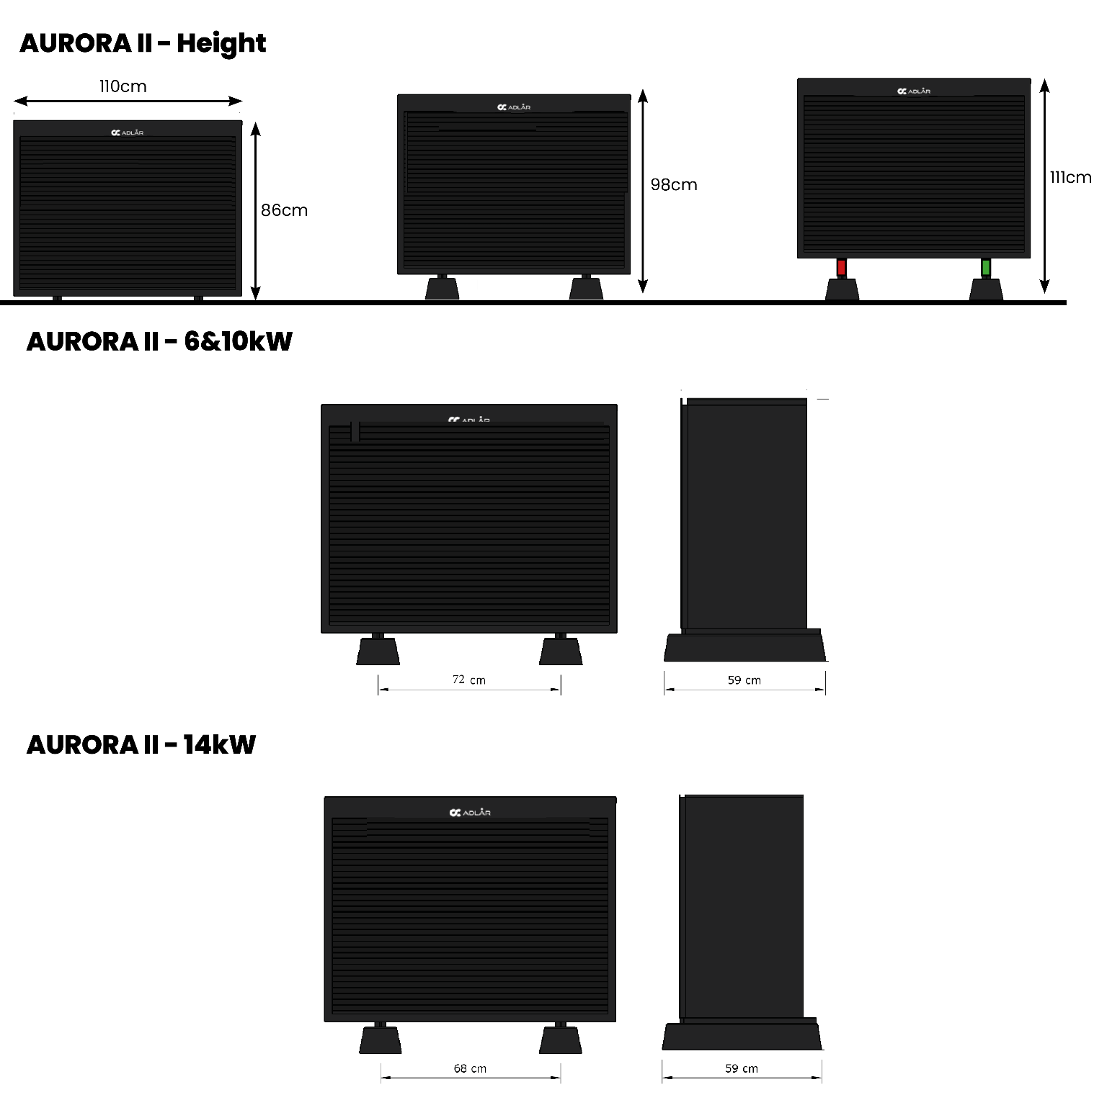
Specifications
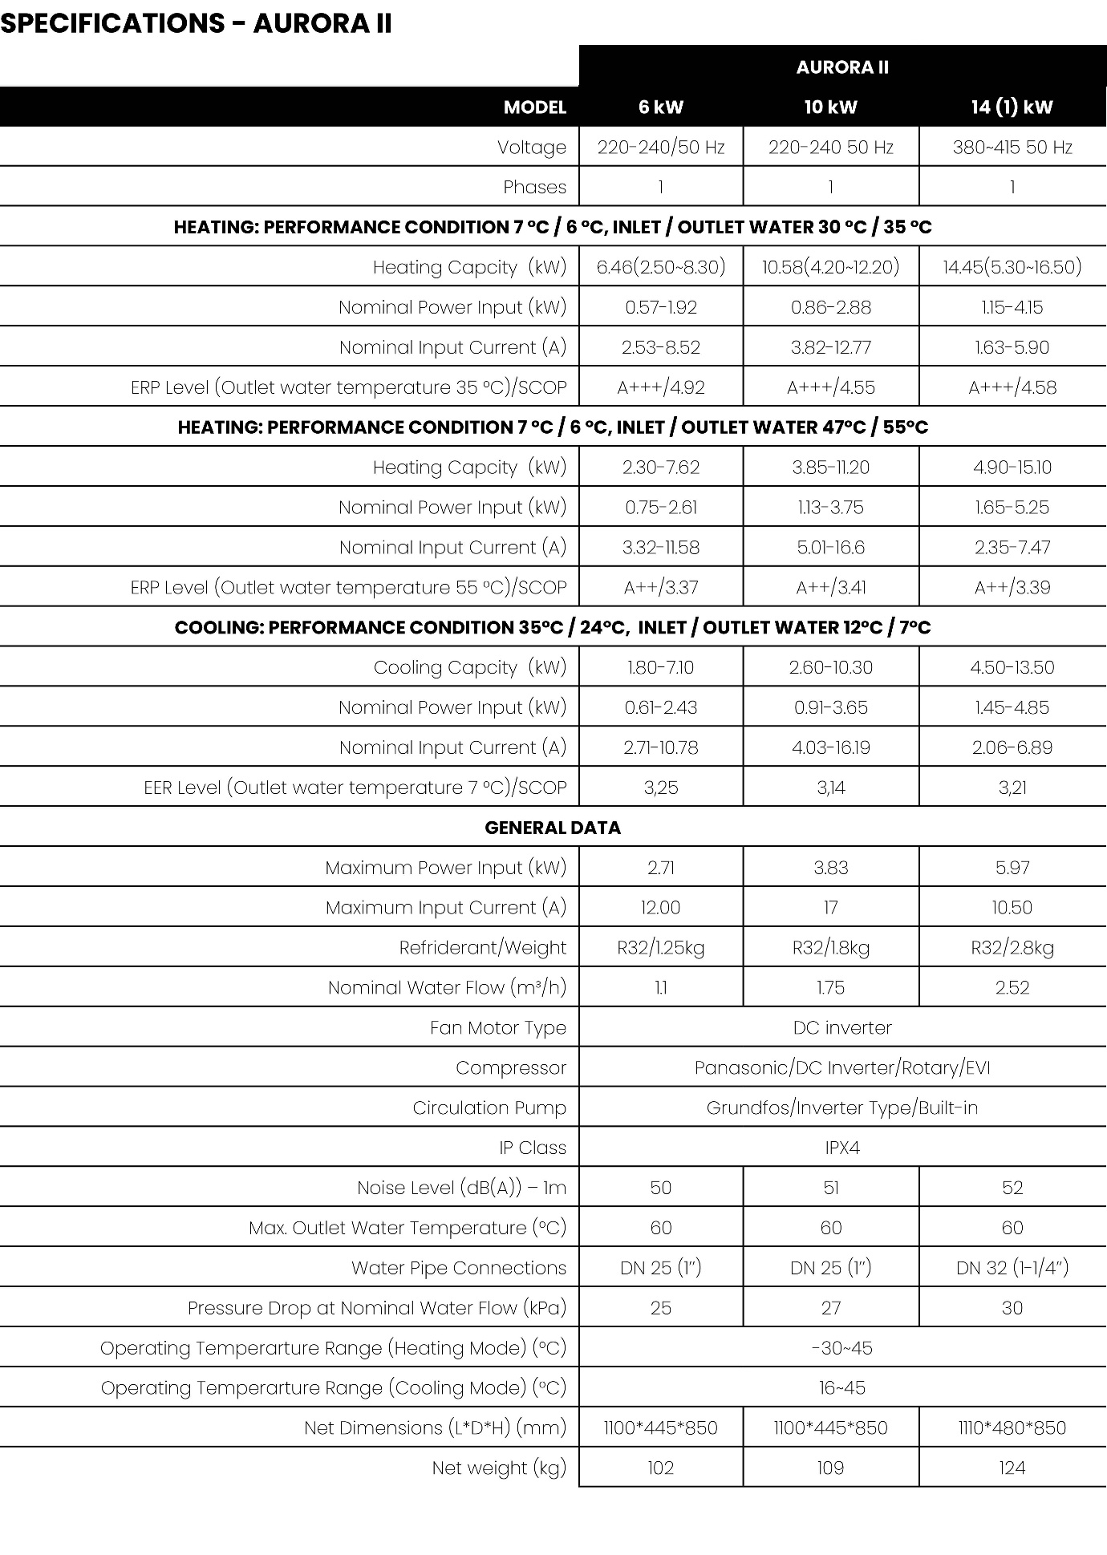

Supporting Documents Provided:
- MCS 020 Sound Calculator
  - https://view.officeapps.live.com/op/view.aspx?src=https%3A%2F%2Fmcscertified.com%2Fwp-content%2Fuploads%2F2025%2F03%2FMCS-020-a-Calculator-FINAL.xlsx&wdOrigin=BROWSELINK
- Photos of Site
- Site Location Plan 1:1250
  - Can be downloaded from https://www.planningportal.co.uk/planning/planning-applications/buy-a-planning-map
  - Once downloaded, add the location of the heat pump

- Block Plan 1:250
  - Can be downloaded from https://www.planningportal.co.uk/planning/planning-applications/buy-a-planning-map
  - Once downloaded, add the location of the heat pump

- Householder Application

Steps for submitting an application
- Fill out this document with your content
- Go to:
  - https://www.planningportal.co.uk/
  - Login/Register
  - Start a new application
- Steps
  - Enter address
  - Enter your details
  - Description of Works
    - “Installation of an air source heat pump”
